Week-6
Q1: Explain the roles of the Driver, Cluster Manager, and Executor in a Spark application.
ANSWER 1:
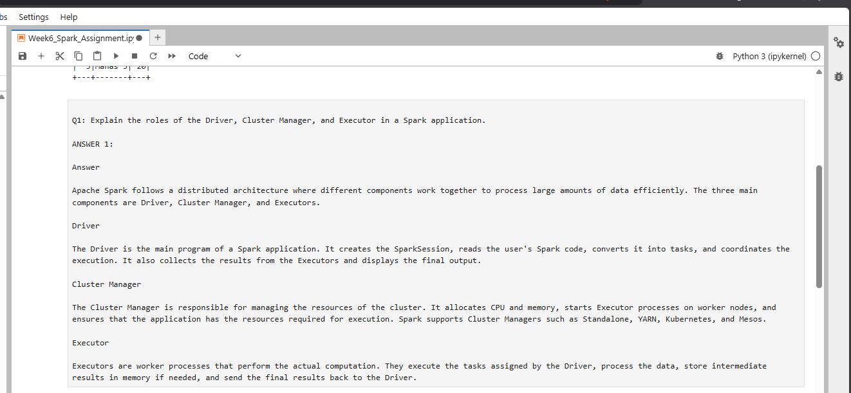

Q2: How does Spark’s Lazy Evaluation strategy improve performance when chain-processing large datasets?
ANSWER 2:
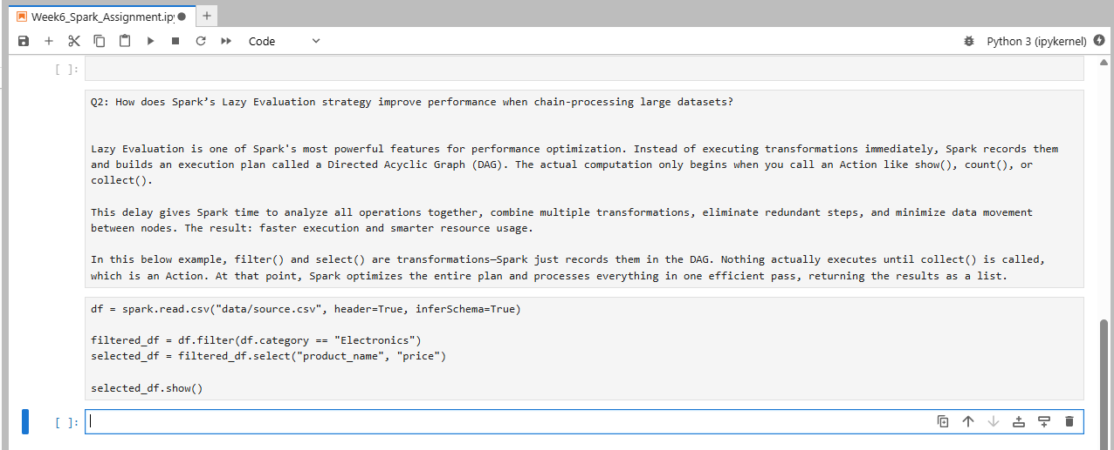
Q3: Write a Spark command to read a CSV file located at "data/source.csv", ensuring the first row is treated as a header and inferSchema is enabled.
ANSWER 3:
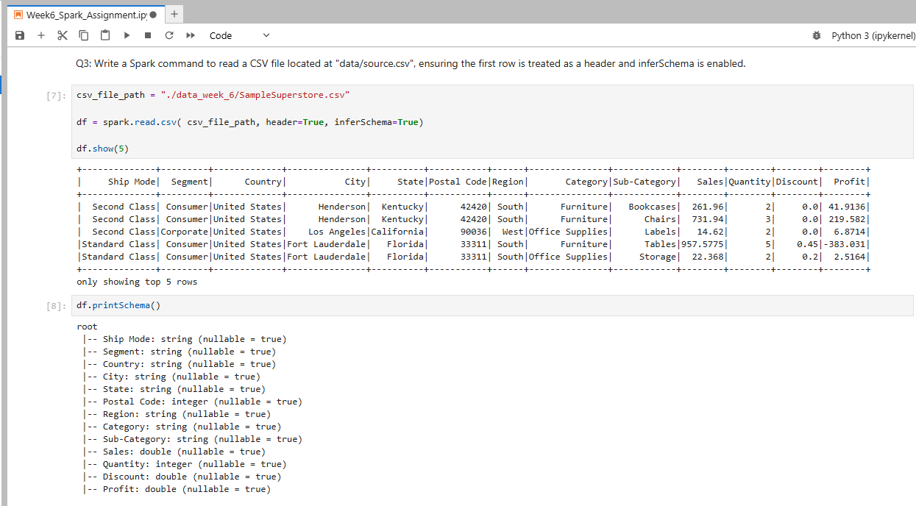

Q4: What is the difference between CSV and Parquet in terms of storage (row-based vs. columnar) and why does it matter for performance?

ANSWER 4:
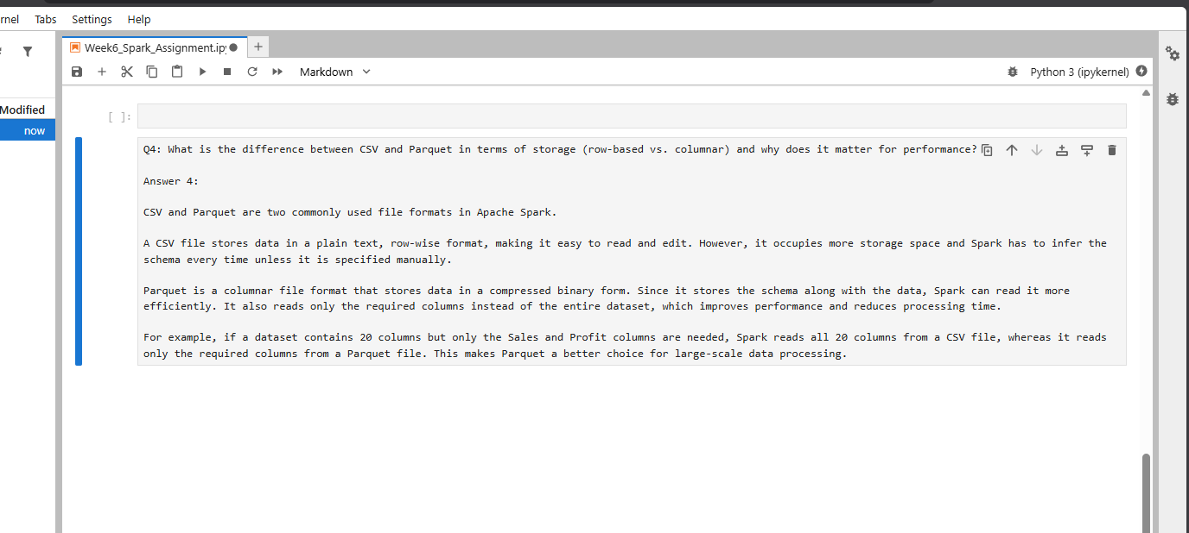

Q5: Given a DataFrame df, write a query to select the columns product_id and price where the category is 'Electronics'.
ANSWER 5:
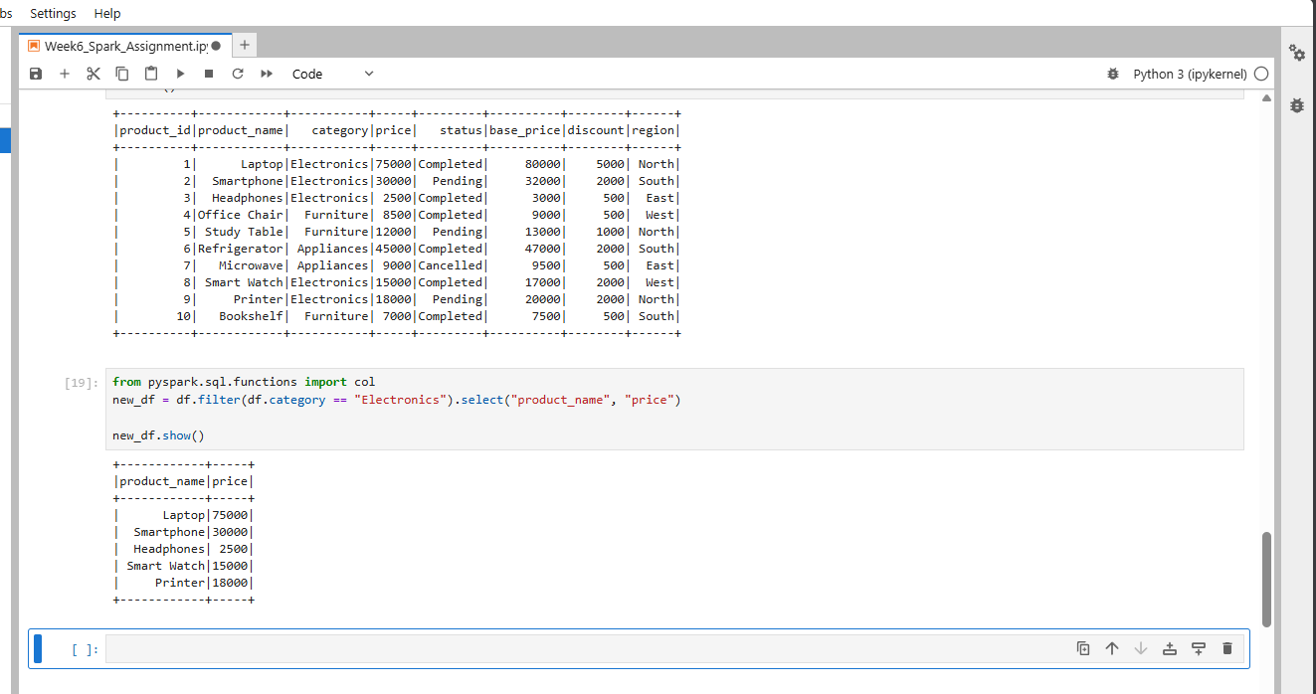

Q6: Write the code to "revise" a DataFrame by renaming the column old_name to new_name and casting the price column from a String to a Double.
ANSWER 6:
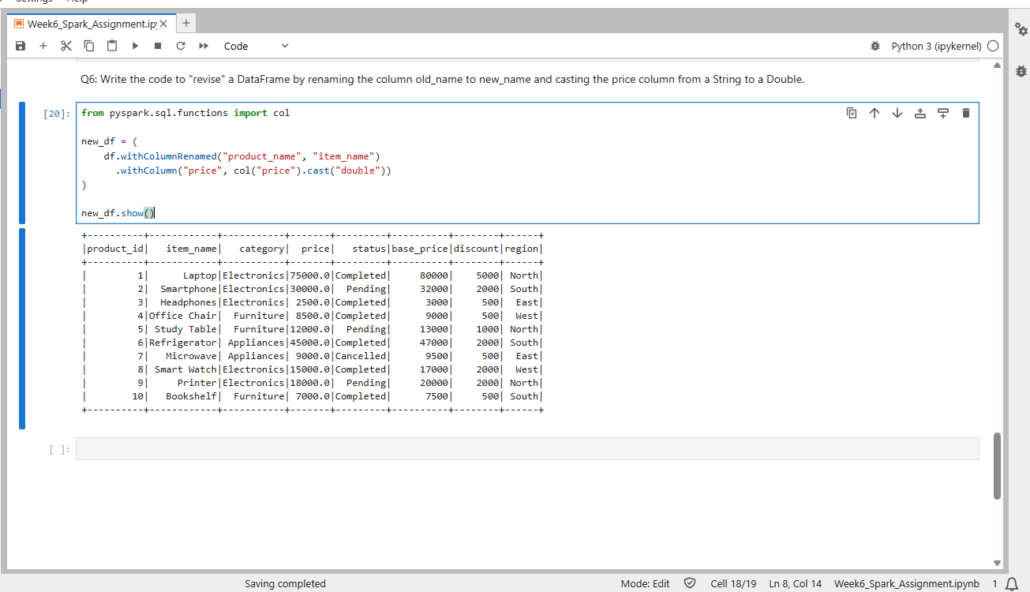

Q7: How does Spark use the Lineage Graph (DAG) to provide fault tolerance if a worker node fails?
ANSWER 7:
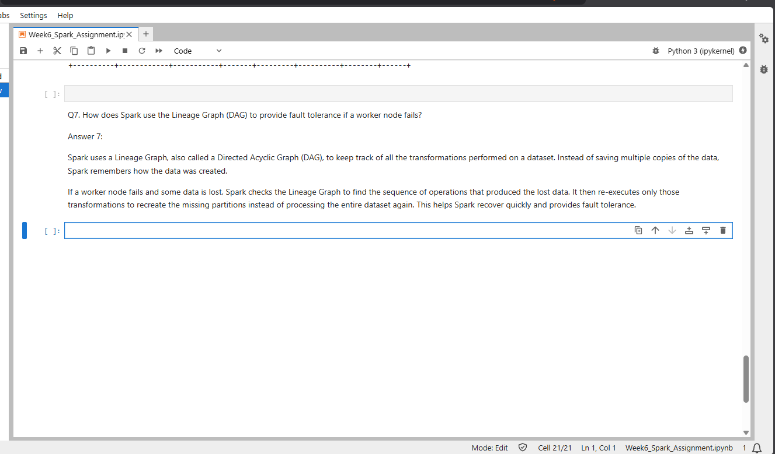

Q8: Write a query to filter a DataFrame df_orders for rows where the status is 'Completed' AND the amount is greater than 1000.
ANSWER 8:
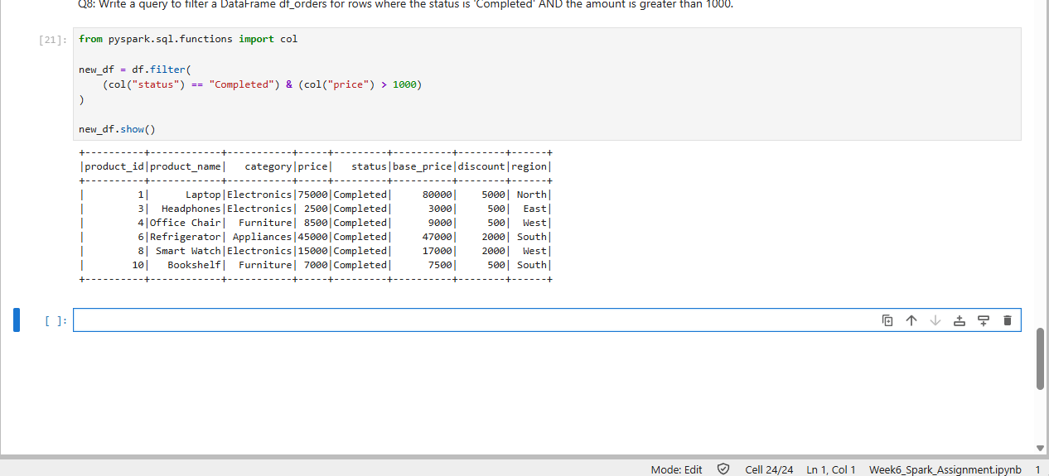

Q9: Explain the concept of Predicate Pushdown in Parquet and how it affects the amount of data loaded into memory.
ANSWER 9:
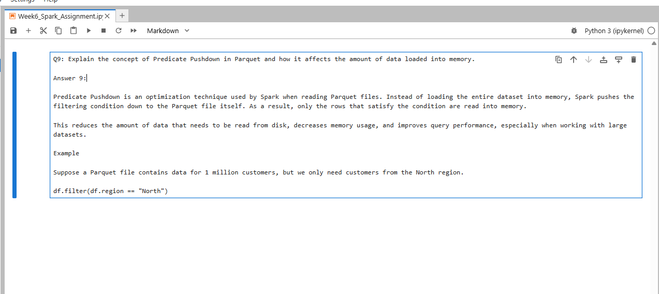
Q10: Write a code snippet to add a new column final_price which is the base_price multiplied by 1.18 (18% tax).
ANSWER 10:
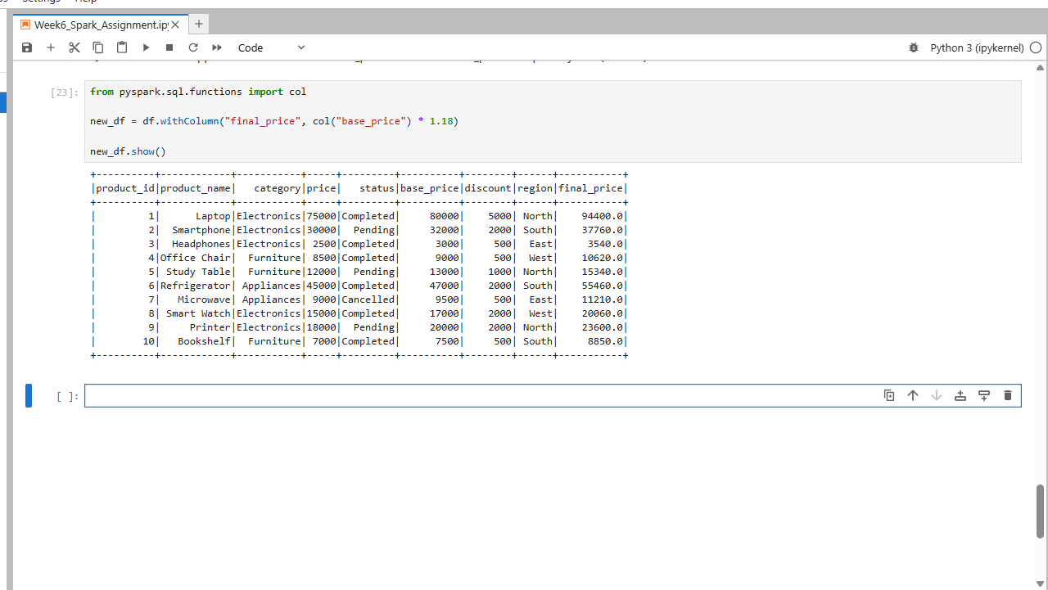
Q11: What is the difference between Transformations and Actions? Provide two examples of each.
ANSWER 11:
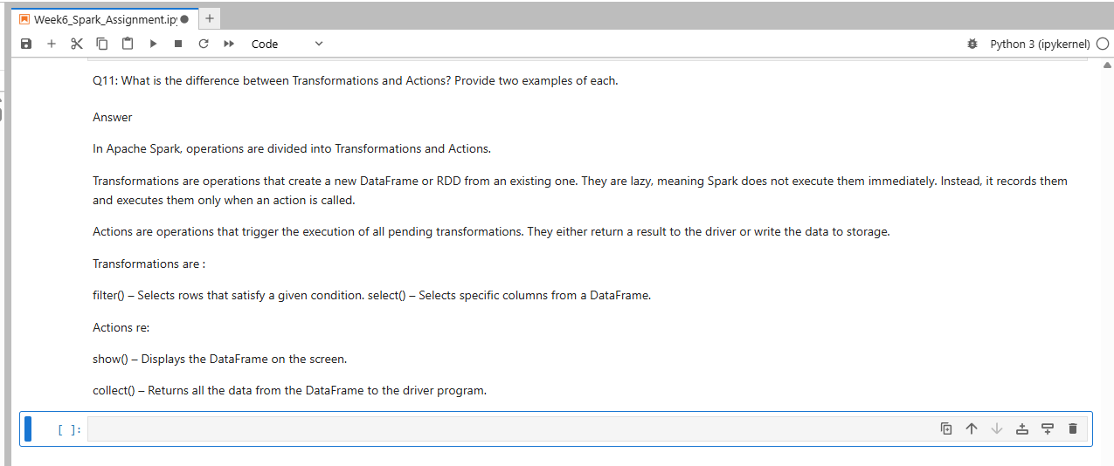
Q12: Write the Spark command to load a Parquet file from "path/to/input", filter out any rows where user_id is null, and save the result as a CSV at "path/to/output".
ANSWER 12:
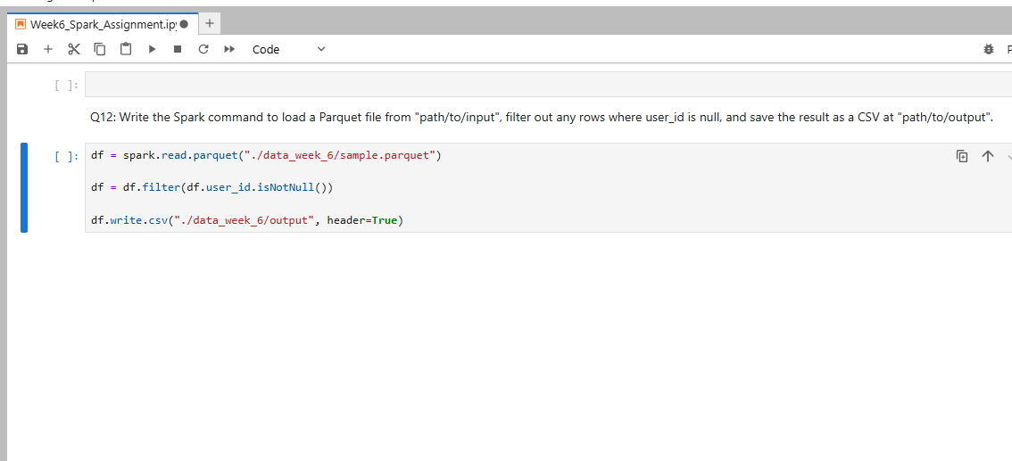
Q13: In Spark Architecture, what is the difference between Client Mode and Cluster Mode?
Answer 13:
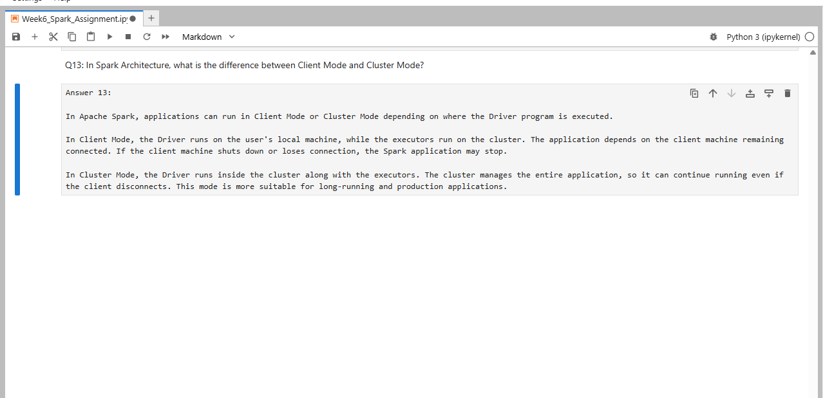
Q14: Write a query to filter a dataset for rows where the region is 'North' OR the priority is 'High'.
ANSWER 14:
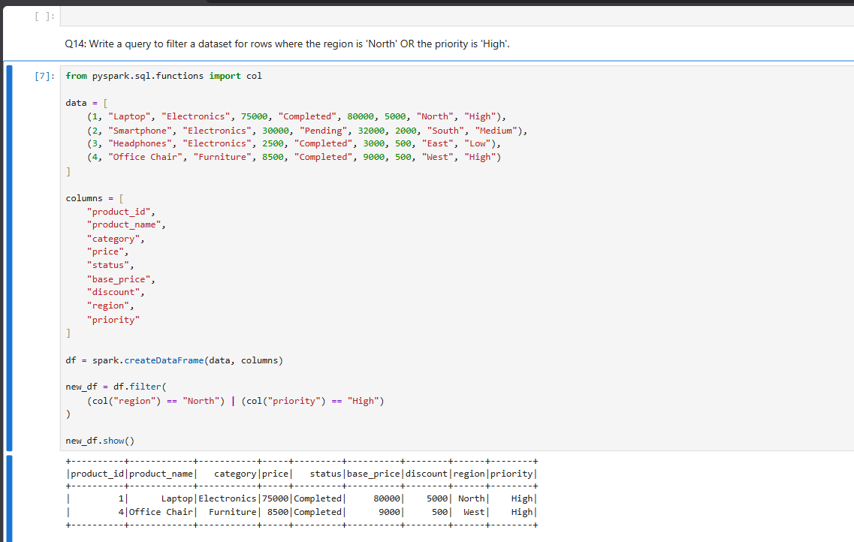
Q15: When exploring a dataset, why is it safer to use .show(5) instead of .collect() on a multi-terabyte dataset?
ANSWER 15:
